

DAR ES SALAAM INSTITUTE OF TECHNOLOGY

DEPARTMENT OF ELECTRICAL ENGINEERING
BACHELOR DEGREE IN ELECTRICAL ENGINEERING
NTA LEVEL 08

PROJECT TITLE: DESIGN OF AN ADVANCED PLC AND HMI BASED MULT-MOTOR
STARTER TRAINING SYSTEM FOR DIT WORKSHOP W12

PROJECT TYPE: PROBLEM SOLVING
PRESENTED BY: JOHN JOFREY STOO
ADMISSION NO: 2103303227391
ACADEMIC YEAR: 2024/2025
SUPERVISED BY: DR. S.F.M. KARUGABA

CERTIFICATION
The undersigned certifies that he has read the project titled “DESIGN OF AN ADVANCED PLC
AND HMI BASED MULT-MOTOR STARTER TRAINING SYSTEM FOR DIT WORKSHOP
W12” for a bachelor of engineering degree in electrical engineering of Dar es Salaam Institute of Technology in Tanzania.
SUPERVISOR: DR. S.F.M. KARUGABA
SIGNATURE: …………………………
DATE: …………………………………

DECLARATION
I, JOHN JOFREY STOO, a student of Dar es Salaam Institute of Technology (DIT) in the department of electrical engineering with a registration number 2103303227391, hereby declare that the project work titled “design of an advanced PLC and HMI-based multi-motor starter training system for DIT workshop W12” is my original work. This project has been carried out for the partial fulfillment of the requirements for the bachelor of engineering in electrical engineering.
I confirm that this work has not been copied from any other source, except where explicitly acknowledged. all sources of knowledge and reference materials have been properly cited and recognized.
STUDENT’S NAME: JOHN JOFREY STOO
Signature: ……………………
Date: …………………............

ACKNOWLEDGEMENT
First and foremost, I extend my heartfelt gratitude to the Almighty God for the gift of life and his endless grace, which have enabled me to successfully complete this project. To Him be all the glory for His unwavering guidance and blessings.
The completion of this project would not have been possible without the invaluable support and guidance of several individuals. I am deeply honored and grateful for the assistance and encouragement I received throughout this journey.
I express my sincere appreciation to the lecturers in the department of electrical engineering for their invaluable advice, guidance, and constructive feedback. Their cooperation, suggestions, and thought-provoking challenges greatly contributed to the success of this work.
I am particularly indebted to my supervisor, Dr. S. F. M. Karugaba, whose unwavering support, insightful guidance, and encouragement played a pivotal role in shaping this project. I am truly grateful for his invaluable assistance and commitment to my success.
To everyone who contributed to the completion of this project in one way or another, I extend my heartfelt thanks.

Contents
CERTIFICATION 2
DECLARATION 3
ACKNOWLEDGEMENT 4
LIST OF ABBREVIATIONS 7
LIST OF FIGURES 8
LIST OF TABLES 9
CHAPTER ONE 10
1.0 Introduction 10
1.1 Background information 10
1.2 Problem statement 11
1.3 Project objectives 11
1.3.1 Main objectives 11
1.4 Significance of the project 12
1.5 Scope of the project 12
1.6 Methodology 12
1.6.1 Literature review 12
1.6.2 Data collection 13
1.6.3 Data analysis 13
1.6.4 System design 13
1.6.5 Simulation of the designed system 13
1.6.6 Building a prototype 13
1.6.7 Testing the prototype 13
1.6.8 Report writing and submission 14
CHAPTER TWO 15
2.0 Literature review 15
2.1 Introduction 15
2.2 Existing system 15
2.21 block diagram of existing system 16
2.3 Drawbacks of the existing system 16
2.4 Proposed system 17
2.41 block diagram of proposed system 18
2.5 Operation of proposed system 18
2.6 Components to be used in the proposed system 19
2.7 Advantages of the proposed system 23
CHAPTER THREE 24
3.0 Data collection 24
3.1 Introduction 24
3.2 Primary data 24
3.2.1 Table of questionnaire results 25
References 26

LIST OF ABBREVIATIONS
AC Alternating Current
DC Direct Current
DIT Dar es Salaam Institute of Technology
DOL Direct – On - line
HMI Human Machine Interface
PLC Programmable Logic Controller

LIST OF FIGURES
Figure 2. 1 block diagram of existing system 16
Figure 2. 2 block diagram of proposed system 18
Figure 2. 3 s7 1200 plc 20
Figure 2. 4 siemens HMI 20
Figure 2. 5 contactor 21
Figure 2. 6 push button 21
Figure 2. 7 over load relay 21
Figure 2. 8 DC power supply 22
Figure 2. 9 cable and Connectors 22

LIST OF TABLES
Table 3. 1 Shows questionnaire results 25

CHAPTER ONE

1.0 Introduction

1.1 Background information
Automation has become a cornerstone of modern industrial operations, with Programmable Logic Controllers (PLCs) and Human-Machine Interfaces (HMIs) playing a vital role in controlling and monitoring industrial processes. In the electrical engineering field, understanding motor operation and control is essential, as electric motors form the backbone of most industrial systems. However, the practical exposure of students to advanced motor control technologies often remains limited, especially in educational institutions. This limitation creates a significant gap between theoretical knowledge and practical application, which can hinder the readiness of graduates to meet industry demands. (Bolton, 2020)
The project titled “Design of an Advanced PLC and HMI-Based Multi-Motor Starter Training System for DIT Workshop W12” addresses this challenge by developing a training system that integrates PLC and HMI technologies. This system is designed to provide hands-on experience to students at the Dar es Salaam Institute of Technology (DIT), enabling them to learn motor control techniques such as Direct-On-Line (DOL), Star-Delta, and Forward-Reverse operations.
The training system incorporates advanced features such as real-time monitoring of motor parameters, including overload protection and phase imbalance detection. By providing a platform for students to interact with modern control technologies, the system aims to bridge the gap between academic learning and industrial practices. It will also enable students to understand the operation, troubleshooting, and optimization of motor systems, skills that are increasingly demanded in today’s automation-driven industries.
In addition to enhancing the technical skills of students, the project contributes to improving the overall quality of training at DIT Workshop W12. By creating a practical and interactive learning environment, the system fosters a deeper understanding of automation concepts and prepares students for the challenges of real-world applications in the electrical engineering field.

1.2 Problem statement
At Dar es Salaam Institute of Technology (DIT), Workshop W12 is equipped with automation tools, but students lack practical knowledge of using these tools, particularly in motor operation via PLCs and HMI. This results in graduates who are not fully prepared for industry needs, where automation is essential. There is a gap in training systems that integrate PLC-based motor control, leaving students without hands-on experience in advanced motor operations like DOL and Star-Delta. This project aims to bridge this gap by providing a PLC and HMI-based motor control training system to equip students with the skills necessary for real-world industrial automation.

1.3 Project objectives
The rapid advancement of automation technologies has increased the demand for skilled professionals capable of managing and operating modern motor control systems. To address this need, the project focuses on developing a practical training platform for students at DIT. By utilizing advanced PLC and HMI technologies, the system aims to equip students with hands-on experience in motor control, parameter monitoring, and troubleshooting, bridging the gap between academic knowledge and industrial requirements.

1.3.1 Main objectives
To design an advanced PLC and HMI-based motor control training system for DIT Workshop W12. 1.3.2 Specific objectives
- To design an advanced PLC and HMI-based multi-motor starter circuit for effective motor control in DIT Workshop W12. ii. To simulate the designed motor starter circuit to validate its functionality and performance using appropriate software tools.
- To build a working prototype of the designed system for practical demonstration and training purposes.
- To test the developed prototype under various operating conditions to ensure reliability, accuracy, and adherence to the intended design specifications.

1.4 Significance of the project
- Enhancing practical skills for students
- Addressing industry needs
- Connecting theory to real-world practice
- Improving motor safety

1.5 Scope of the project
This project focuses on designing of an advanced PLC and HMI-based training system for controlling multiple motor starters at DIT Workshop W12. The system supports various motor control techniques, including Direct-On-Line (DOL) and Star-Delta. It incorporates real-time monitoring features for motor parameters such as overload protection and phase imbalance detection to ensure operational safety. An intuitive HMI interface is integrated for user-friendly control and visualization of motor parameters. The project aims to provide a hands-on training platform, bridging the gap between theoretical knowledge and practical skills in automation. It is designed to be scalable and adaptable, allowing future expansion and upgrades. Ultimately, the system enhances students' readiness for the automation-driven industrial environment

1.6 Methodology
The methodology outlines the step-by-step process undertaken to successfully design and implement the advanced PLC and HMI-based multi-motor starter training system. Each stage was carefully planned and executed to ensure the project's objectives were met effectively.

1.6.1 Literature review
An extensive review of existing research and publications on PLCs, HMIs, motor control systems, and training platforms was conducted. The review helped identify gaps in current systems and provided insights into best practices and innovative features to include in the design. This foundation guided the system’s development and ensured alignment with industry standards.

1.6.2 Data collection
Information was gathered through observations, interviews with lecturers and students, and analysis of existing training systems in Workshop W12. Key data points included the challenges faced in practical motor control training and the specific features required for a comprehensive learning platform.

1.6.3 Data analysis
The collected data was analyzed to identify the limitations of the current system and establish the technical and functional requirements of the new system. The analysis helped define critical parameters such as motor starter configurations, monitoring needs, and user interaction features.

1.6.4 System design
The design phase involved creating detailed circuit diagrams, developing PLC logic, and designing the HMI interface. This stage also included defining the hardware components, wiring configurations, and software requirements to ensure seamless integration and functionality.

1.6.5 Simulation of the designed system
Before building the physical prototype, simulations were conducted using software tools to verify the functionality of the control logic and monitoring features. These simulations provided a cost-effective way to identify and resolve potential issues.

1.6.6 Building a prototype
A working prototype of the system was constructed using the selected hardware components, PLC, and HMI. The prototype served as a tangible model for testing and demonstrating the system’s features and capabilities.

1.6.7 Testing the prototype
The prototype was tested under various scenarios to evaluate its performance, reliability, and ability to handle multiple motor operations. Any issues identified during testing were resolved to optimize the system’s efficiency and safety.

1.6.8 Report writing and submission
A comprehensive report documenting the project’s objectives, methodology, design process, outcomes, and recommendations was prepared. The final report was submitted as part of the academic requirements and for review by stakeholders.

CHAPTER TWO

2.0 Literature review

2.1 Introduction
The integration of automation technologies, such as Programmable Logic Controllers (PLCs) and Human-Machine Interfaces (HMIs), has revolutionized motor control systems in industrial applications. These technologies offer precise, reliable, and efficient control and monitoring of motors, which are the backbone of industrial operations. Existing research highlights the importance of providing practical training platforms to equip engineering students with the skills necessary to operate and troubleshoot such advanced systems. (Petruzella, 2016)
Numerous studies have explored the design and application of PLC and HMI-based systems in various fields, emphasizing their effectiveness in enhancing operational efficiency and safety. However, limited work has been directed toward developing comprehensive training systems specifically tailored for educational purposes, particularly for multi-motor starters in institutional workshops like DIT Workshop W12.
This literature review examines previous work on PLC and HMI-based motor control systems, motor starter configurations such as Direct-On-Line (DOL), Star-Delta, and Forward-Reverse, and the role of real-time monitoring in ensuring system reliability. It also explores the challenges and best practices in implementing such systems for educational and training purposes. The findings provide a foundation for designing a robust and interactive training system that aligns with modern industrial requirements. (Frank, 2019)

2.2 Existing system
DIT Workshop W12 has several automation tools for motor control, but their utilization is limited due to the absence of an integrated training system. Currently, students rely mostly on theoretical knowledge, with minimal practical exposure to advanced technologies like PLCs and HMIs. Individual motor starters, such as Direct-On-Line (DOL) and Star-Delta, are operated manually or with basic automation, lacking advanced features for real-time monitoring.
Critical motor parameters, including overload and phase imbalance, cannot be observed during operation, limiting students' understanding of system performance and safety. Additionally, the system does not support multi-motor operations or provide a centralized control and monitoring interface. This setup fails to simulate real-world industrial scenarios, leaving students unprepared for automation-driven environments.
The lack of a hands-on, interactive platform highlights the need for a modern training system to bridge the gap between academic learning and practical skills in motor control and automation

2.21 block diagram of existing system
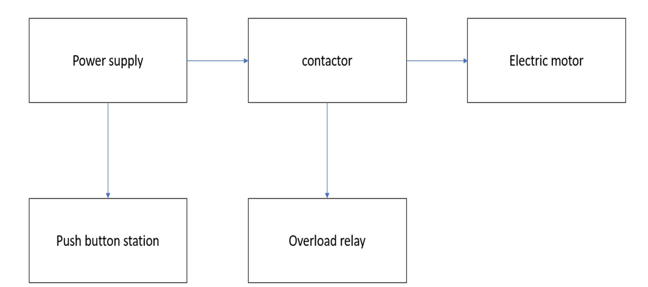
Figure 2. 1 block diagram of existing system

2.3 Drawbacks of the existing system
- Lack of advanced monitoring features
The current system does not provide real-time monitoring of critical motor parameters such as overload and phase imbalance, leading to limited understanding and risk of equipment damage.
- Minimal practical exposure
Students have minimal hands-on experience with modern automation technologies like PLCs and HMIs, making it challenging to connect theoretical concepts with practical applications.

- Absence of multi-motor control
The system is not designed to handle multiple motor operations simultaneously, restricting its capability as a comprehensive training tool.
- Manual operation limitations
Most motor control operations rely on manual or basic automation methods, which are outdated and do not align with current industry practices.
- No centralized control and visualization
The existing system lacks a centralized interface, such as an HMI, to allow efficient control and visualization of motor operations, making it less interactive and user-friendly.

2.4 Proposed system
The proposed system is an advanced PLC and HMI-based multi-motor starter training platform designed specifically for DIT Workshop W12. It aims to address the limitations of the current setup by offering a comprehensive and interactive solution for motor control training. The system integrates multiple motor starter configurations, including Direct-On-Line (DOL), Star-Delta, and Forward-Reverse operations. These configurations will allow students to gain practical experience with various motor control techniques commonly used in industrial automation.
The system incorporates a Human-Machine Interface (HMI) as a centralized platform for control and monitoring. Through the HMI, users can easily select motor operation modes, visualize real-time motor parameters, and receive feedback on system performance. Parameters such as overload and phase imbalance are monitored continuously using integrated sensors. Any anomalies detected are processed by the PLC and displayed on the HMI, ensuring students understand critical safety and operational considerations. (Gowri, 2017)
Designed as a training platform, the system provides a hands-on learning experience that bridges the gap between theoretical knowledge and practical skills. It simulates real-world industrial conditions, enabling students to operate, monitor, and troubleshoot motor systems effectively. Additionally, the modular design of the system allows for scalability, making it adaptable for future upgrades and expansions to include additional motors or advanced features.

By integrating advanced automation technologies into the workshop, this system ensures students are better prepared for automation-driven industries. It enhances their competency in motor control, troubleshooting, and the practical application of PLCs and HMIs, fostering a deeper understanding of modern industrial systems.

2.41 block diagram of proposed system
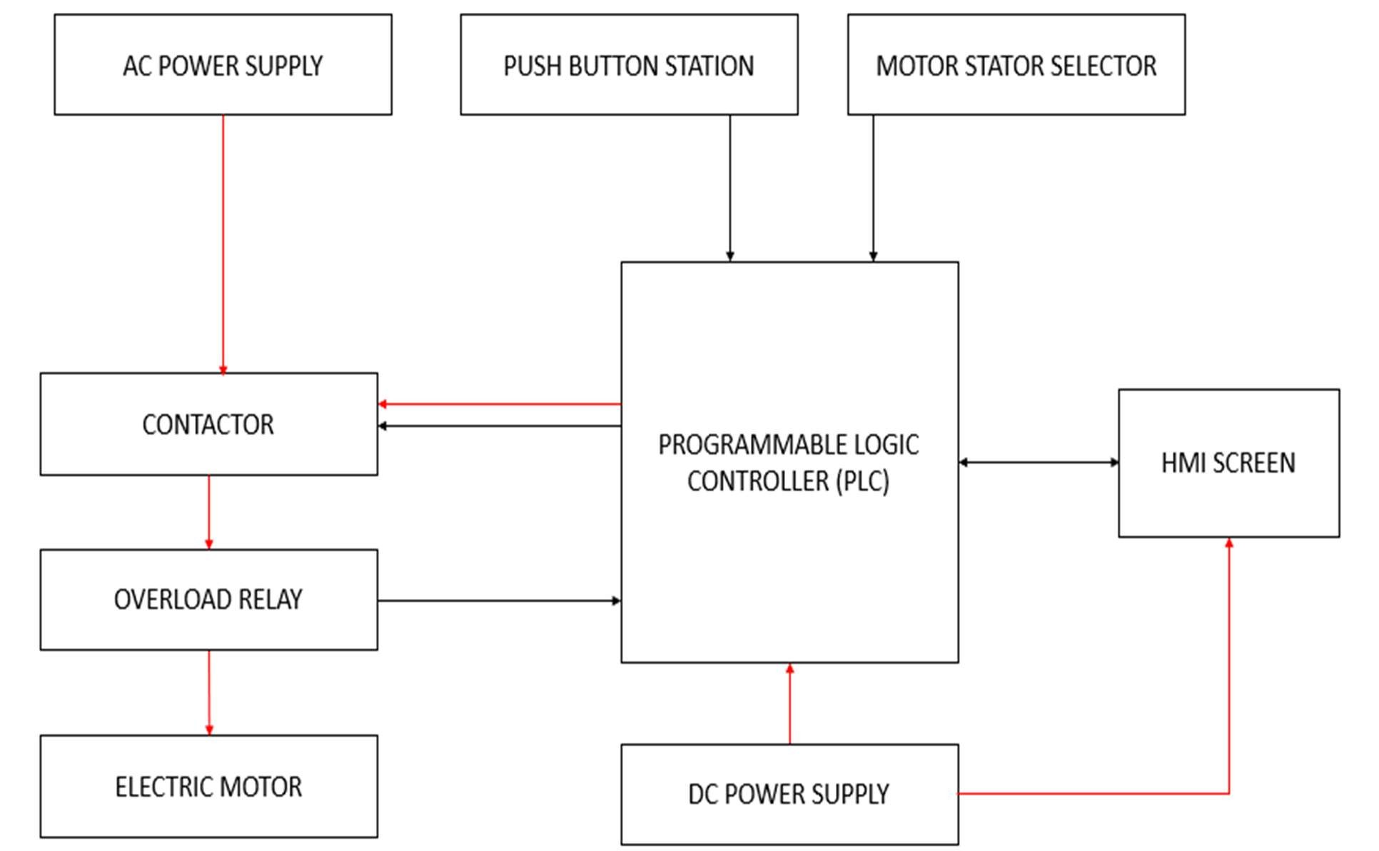
Figure 2. 2 block diagram of proposed system

2.5 Operation of proposed system
The proposed system is designed to provide students with hands-on experience in selecting, operating, and controlling motors using different starting methods such as Star-Delta and Direct-On-Line (DOL). Here's how the system will work:
Proposed system workflow
- Motor Selection and Starting Mode
Upon interacting with the HMI or using the push button interface, the student will first choose the type of motor starter they wish to operate either Star-Delta or Direct-On-Line (DOL).
- Motor Operation
After selecting the starting method, the student will connect the motor starter type (e.g. the motor contactor for DOL or the Star-Delta control circuit). The student will then be able to control the motor's direction using the HMI or push buttons. They can choose to run the motor either forward or reverse, simulating real-world motor control applications.
- PLC control
The motor operation is controlled by the PLC. The PLC will be programmed using Ladder Logic, which is a graphical programming language commonly used for industrial automation. Ladder Logic diagrams will be provided as part of the training material, teaching students how to program the PLC to control the motor’s operation, ensuring they gain practical experience in writing and understanding PLC programs.
- System protection and feedback
The system will include safety features such as overload protection, which will automatically stop the motor if it operates beyond its safe limits. The HMI will display real-time feedback on the motor's status, such as when motor is running forward, reverse and when there is an overload.

2.6 Components to be used in the proposed system
The proposed system will utilize several components to achieve motor control, monitoring, and automation via PLC and HMI. Here is a list of the key components:
- Programmable Logic Controller (PLC)
The PLC will be the core component responsible for controlling the motor's operation, including starting methods (Star-Delta, DOL), direction (Forward/Reverse), and safety features (overload protection, phase imbalance detection).
There are various types of Programmable Logic Controllers (PLCs) based on their size, functionality, and application. Here are the main types of PLCs:

  - Compact PLC
Also known as fixed PLCs, they come with a fixed number of I/O points and built-in power supply, CPU, and communication ports in a single unit. They are used in small-scale automation systems like conveyors, packaging machines, and simple motor control.
  - Modular PLC
These PLCs have a flexible configuration, where I/O modules, power supply, and CPU are separate units and can be added or replaced as needed. Also, they are used in medium to large-scale automation systems requiring scalability, such as manufacturing plants and process industries (Curtis, 2020)
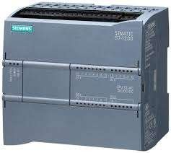
Figure 2. 3 s7 1200 plc
- Human-Machine Interface (HMI)
The HMI will provide a user interface for students to select motor starter types (Star Delta or DOL), control the motor's direction (Forward/Reverse), and monitor system status.
Here are the main types of Human-Machine Interfaces (HMIs) based on their design, functionality, and application which are as following, Push-Button Replacer HMI, Text-Based HMI, Graphical HMI, Touch-Screen HMI and PC-Based HMI (Frank,
2019)
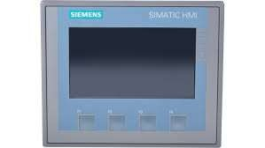
Figure 2. 4 siemens HMI
- Contactor
Motor contactors will be used for controlling the connection between the motor and the power supply. Two types of starters will be used:
Direct-On-Line (DOL) Starter: For simple motor control where the motor is directly connected to the power supply.
Star-Delta starter: For reducing the motor's starting current by initially connecting the motor in Star configuration and later switching to Delta. (Singh, 2018)
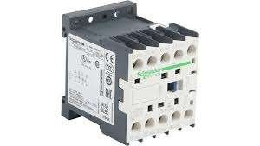
Figure 2. 5 contactor
- Push buttons (Start/Stop)
These will be used for manual motor operation, allowing students to start or stop the motor via physical buttons on the control panel.
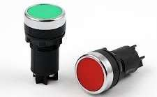
Figure 2. 6 push button

- Overload protection relay
This component will protect the motor from running under excessive load by disconnecting the motor if the current exceeds the preset limit.
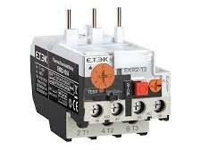
Figure 2. 7 over load relay
- Power supply unit
A power supply unit will provide the necessary DC voltage to operate the PLC, HMI, sensors, and other components.
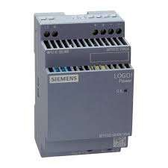
Figure 2. 8 DC power supply
- Cable and connectors
Standard cable and connectors will be used to make connections between the PLC, motor, contactors, and other components in the system.
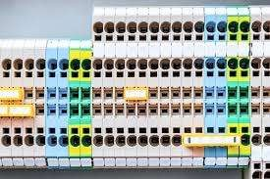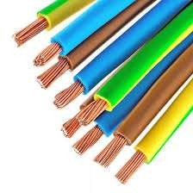
Connector AC cable
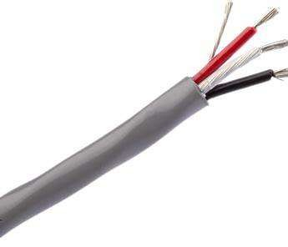
DC cable
Figure 2. 9 cable and Connectors
These components work together to form an integrated system for hands-on training in motor control, providing students with valuable experience in working with industrial automation systems. (Chen, 2021)

2.7 Advantages of the proposed system
- Enhanced practical skills
- Improved understanding of automation
- User friendly interface
- Industry relevant training

CHAPTER THREE

3.0 Data collection

3.1 Introduction
Data collection plays a crucial role in ensuring the project meets its intended objectives. Effective data collection helps in understanding the existing challenges, technical requirements, and key parameters necessary for developing a functional and efficient training system
The data collection process involves gathering information on motor control techniques, PLC and HMI integration, monitoring parameters such as overload and the training needs of students at DIT. This data is obtained through various methods, including literature reviews, field observations, interviews with students, and analysis of existing training equipment in Workshop W12.
The data collected were of two types
- Primary data.
- Secondary data.

3.2 Primary data
Primary data collection refers to the process of gathering firsthand information directly from original sources. In the context of this project, "Design and Implementation of an Advanced PLC and HMI-Based Multi-Motor Starter Training System for DIT Workshop W12," primary data is essential to understand the actual requirements, challenges, and conditions of motor control training at DIT.
A survey questionnaire was conducted among students at the Dar es Salaam Institute of Technology (DIT), particularly those participating in practical sessions in Workshop W12, to assess their experiences, challenges, and understanding of motor control systems. The survey was designed to gather firsthand insights into their knowledge of motor starters, including their familiarity with Direct-On-Line (DOL), Star-Delta, and Forward-Reverse operations, as well as their exposure to Programmable Logic Controllers (PLCs) and Human-Machine Interfaces (HMIs) in controlling motors.

3.3 Secondary data collection
Secondary data collection involves gathering information from existing sources that have already been published or documented. In this project, “Design and Implementation of an Advanced PLC and HMI-Based Multi-Motor Starter Training System for DIT Workshop W12,” secondary data played an important role in building a strong theoretical foundation and understanding best practices in automation and motor control training systems and also physical observation was carried out in Workshop W12 to identify and assess the different types of motors available.

3.3.1 Table of questionnaire results
S/N | QUESTIONS | RESPONSE
1 | How familiar are you with motor control methods such as Direct-On Line and Star-Delta | Very familiar
2 | Have you ever used automation tools like PLCs or HMIs during your practical sessions? | No
3 | Do you think integrating HMI into motor control training will improve your learning experience? | Yes
4 | Would hands-on automation training help you feel better prepared for industrial environments? | Yes
5 | If we develop this system (PLC and HMI-based motor control training system), do you think it will help you learn motor control and automation more effectively? | Yes

Table3. 1 Shows questionnaire results
The questionnaire results indicate a strong interest in automation-based motor control training, particularly using PLCs and HMIs, with many students recognizing their importance but facing challenges in programming, wiring, and troubleshooting.

3.3.2 Table of motor specification for workshop W12.
S/N | Motor name plate | Motor type | Starter type | Power rating | Current | voltage | Speed | Phase | Frame size | Manufacturer
1 | Motor A | Induction motor | Start delta | 7.5kw/10HP | 15A | 400V | 1450  RPM | 3  phase | 132M | ABB
2 | Motor B | Induction motor | DOL | 3.0kw/4HP | 6.5A | 400V | 1400  RPM | 3  phase | 100L | WEG
3 | Motor C | Squirrel cage motor | DOL | 2.2kw/3HP | 5A | 400V | 1420  RPM | 3  phase | 90S | TECO
4 | Motor D | Induction motor | Star delta | 11kw/15HP | 22A | 400V | 1480  RPM | 3  phase | 160M | WEG
5 | Motor C | Induction motor | DOL | 1.5kw/2HP | 3.2A | 230V | 1380  RPM | 3  phase | 80M | Siemens

Table 3.2 shows motor specification data collection table for workshop w12

CHAPTER FOUR

4.0 DATA ANALYSIS

4.1 Introduction
Data analysis is the process of examining, organizing, interpreting, and modeling data to uncover meaningful insights, draw conclusions, and support effective decision-making. In this project, data analysis focuses specifically on evaluating the collected information to determine appropriate component values, select suitable integrated circuits, and define power supply requirements for the entire system. The analysis helps to connect the gathered data with the technical specifications and design calculations, ensuring that each aspect of the system is logically aligned with the practical needs and constraints identified during data collection.
The analysis was carried out in the following system components.

4.1.1 PLC (Programmable logic controller)
The plc is the core of the control system, used to automate the motor starter operations (Direct On line and Star - delta). It processes inputs from push buttons and sensors and sends outputs to control devices such as contactors.
4.1.2 Table for programmable logic controller (PLC) specifications:
S/N | Parameter | specification
1 | Power Supply | 24V DC
2 | Digital Inputs/outputs | 14/10
3 | Current consumption | 0.5A to 2A
4 | Communication | Ethernet
5 | programming | Ladder logic
6 | Memory | 10KB

Power requirements:
Plc maximum load current = 0.5 – 2 A
Power supply = 24v
Power = IV
= (0.5 - 2) A x 24V
= 12 – 48watts
4.1.2 Human Machine Interface (HMI)
The HMI provides a graphical interface for users to select motor operation modes, monitor real-time system status, and receive fault alerts.
Specifications:
- Screen: 7-inch TFT touchscreen
- Resolution: 800 x 480 pixels
- Communication: Ethernet
- Supported Functions: Tag monitoring, mode selection, system alarms
4.1.3 contactors
Electromagnetic switches used to connect or disconnect power to motors. Different sets are used for DOL and Star-Delta configurations
Motor full load current (FLC) calculation
FLC = $\frac{P}{\sqrt{3} VCos∅η}$
FLC = $\frac{(3-10)KW}{\sqrt{3} X 400X0.85X 0.9}$
FLC = (5.6 -18.87) A
Contactor rating should be ≥ 1.25 of motor current
= 1.25 x 18.87A
= 23.58A ~25A

Contactor model
Size: D0910 LC1, AWG 10 - 18
Coil voltage: 24V DC (ideal for PLC control)
Contacts: 3 main+ 1 NO auxiliary contact
4.1.4 overload relay protection
An overload relay is a protective device used in motor circuits to protect the motor from drawing too much current for too long. It monitors the motor’s current and disconnects the motor if the current exceeds a safe limit, preventing overheating and damage.

FLC = $\frac{P}{\sqrt{3} VCos∅η}$
FLC = $\frac{10KW}{\sqrt{3} X 400X0.85X 0.9}$
FLC = 18.9 A
Overload relay safety factor = 1.15
= 1.15 x 18.9A
= 21.735A ~25A

References
Bolton, W., 2020. Programmable Logic Controllers. 6 ed. Oxford: Elsevier.
Chen, X. a. L. Y., 2021. Advanced Motor Control Systems: Theory and Practice. Beijing: Tsinghua.
Curtis, A., 2020. Industrial Automation: Concepts and Applications. 3 ed. London: Routledge.
Frank, 2019. Human Machine Interface: Design and Implementation. 3 ed. London: Springer.
Frank, D., 2019. Human Machine Interface: Design and Implementation. London: Springer.
Gowri, S., 2017. Automation Systems in Industrial Applications. 2 ed. Chennai: Wiley India.
Petruzella, F., 2016. Programmable Logic Controllers. 5 ed. New York: McGraw-Hill Education.
Singh, R., 2018. Electrical Machines and Motor Control. New Delh: PHI Learning.

